***BEEE EVALUATION***

**Aim:**

**Design a dice that displays a A. Red background when 6 comes up B. Green background when 4 comes up . C. Blue background when 2 comes up.**

**Apparatus used:**

Arduino, breadboard, connecting wires, LDR, resistor, LED.

**Principle used:**

A **seven segment display** consists of **7** LEDs arranged in the form of Square '8' and a single **LED** as dot character. ... A **7 seven segment display** is an electronic **display**, which **displays** 0-9 digital information. They are available in common cathode mode and common anode mode.

**Circuit Diagram:**

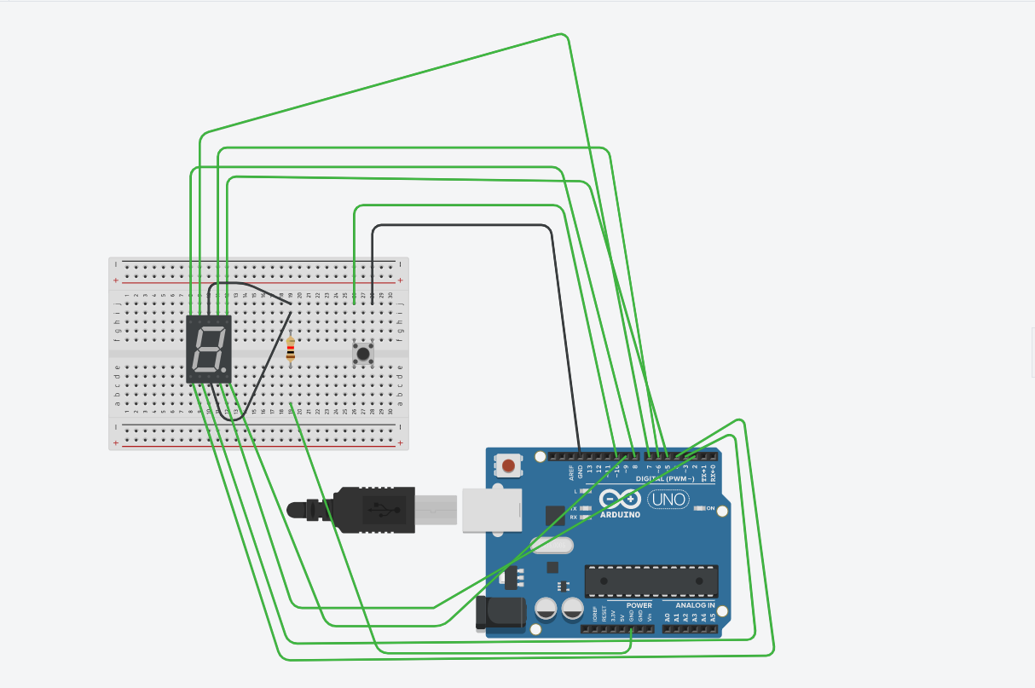

**Precautions used:**

1. Always use the arduino without plugging it.
2. Don’t touch the energized wires and equipments.

**Source Code:**

int s1 = 10;

int s2 = 9;

int s3 = 8;

int s4 = 7;

int b = 11;

int bs;

long r;

void setup () { pinMode (s1, OUTPUT);

pinMode (s2, OUTPUT);

pinMode (s3, OUTPUT);

pinMode (s4, OUTPUT);

pinMode (b, INPUT);

randomSeed(analogRead(0));

}

void loop()

{

bs = digitalRead(b);

if (bs == LOW)

{

r = random(1, 7);

shuffle();

if (r == 1)

{

one();

}

if (r == 2)

{

two();

}

if (r == 3)

{

three();

}

if (r == 4)

{

four();

}

if (r == 5)

{

five();

}

if (r == 6)

{ six();

}

delay(3000);

}

else {

digitalWrite (s1, LOW);

digitalWrite (s2, LOW);

digitalWrite (s3, LOW);

digitalWrite (s4, LOW);

}

}

void off()

{

digitalWrite (s1, LOW);

digitalWrite (s2, LOW);

digitalWrite (s3, LOW);

digitalWrite (s4, LOW);

}

void shuffle()

{

one();

delay(100);

off();

delay(100);

two();

delay(100);

off();

delay(100);

three();

delay(100);

off();

delay(100);

four();

delay(100);

off();

delay(100);

five();

delay(100);

off();

delay(100);

six();

delay(100);

off();

delay(200);

}

void one()

{

digitalWrite (s4, HIGH);

}

void two()

{

digitalWrite (s2, HIGH);

}

void three()

{

digitalWrite (s4, HIGH);

digitalWrite (s2, HIGH);

}

void four()

{

digitalWrite (s1, HIGH);

digitalWrite (s3, HIGH);

}

void five()

{

digitalWrite (s1, HIGH);

digitalWrite (s3, HIGH);

digitalWrite (s4, HIGH);

**Problems faced:**

1. Connecting the equipments in right phases.
2. Problem faced in uploading the code to the board.
3. Errors in source code.

**Solutions to problems faced:**

1. By connecting the anode of the LED to the ground.
2. Correcting the loops initialisation.